
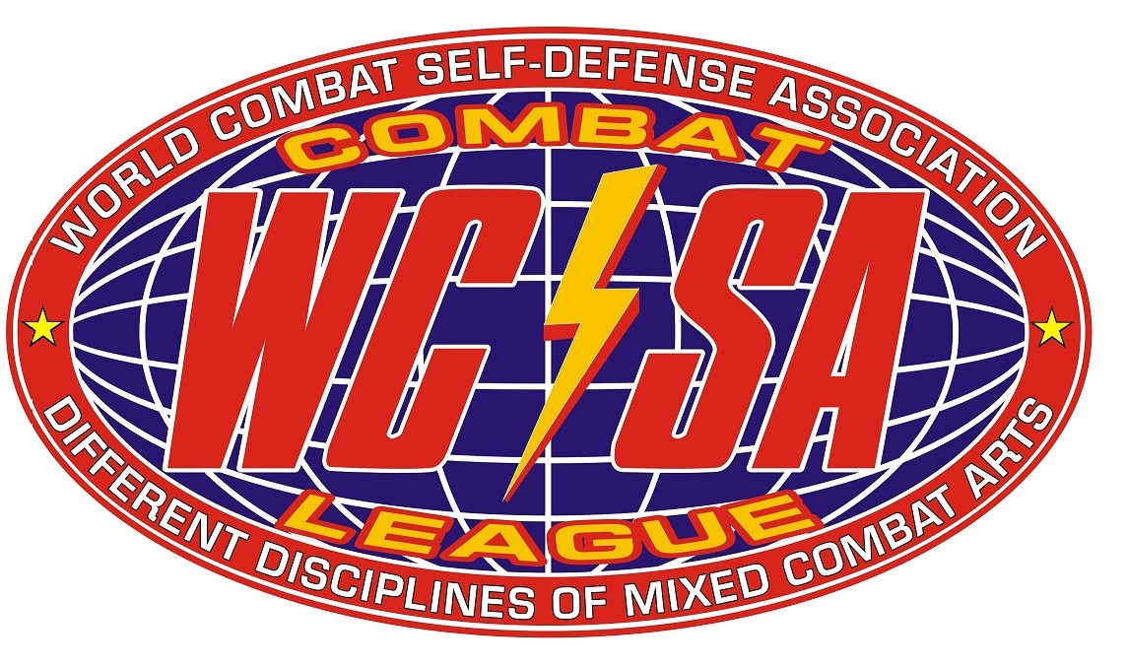

INTERCONTINENTAL COMBAT TOURNAMENT

“Black Sea Cup 2013”
World Cup Stage

INTERNATIONAL MASTER CLASS FOR ATHLETES AND INSTRUCTORS, REFEREE AND JUDGES SEMINAR, INSTRUCTOR AND ATHLETES CERTIFICATION
WITH

Dan “The Beast” Severn
and
PRO/AMA FIGHT SHOW – “COMBAT RING”

ODESSA/UKRAINE, 26 JUNE-2 JULY 2013

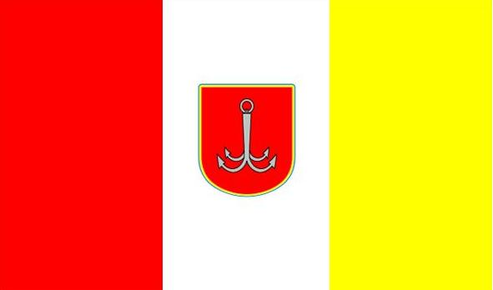

men, women, juniors, cadets, kids
DEMO/SELF-DEFENSE, SAFE-POINT, MIX-WRESTLING
“МIXED COMBAT АRTS”: SAFE-COMBAT, LIGHT-COMBAT, FREE- COMBAT, MIX-COMBAT
& DIFFERENT DISCIPLINE OF KICKBOXING

WWW.COMBATSD.COM

1) DATE: 24th -25th June – arrival of the tournament participants. 2nd July 2013 – departure.

2) PLACE: Odessa (Ukraine) International Airport. Transfer to Koblevo (Hotel “Vinnitsa”).

3) PROGRAM OF THE EVENT:

24-25 June | arrival
26 June | registration, medical, WEIGHT & PASSPORT control
27-28 June | International master class, referee and judges seminar and certification with Dan “The Beast” Severn
28 June -30 June | Qualification fights in all age and weight categories for each discipline and
30 June | Gala- Finals at Open Stadium in Odessa City  PRO/AMA Fight Show “Combat Ring”
1 July | Finals and medal ceremony
2 July | departure

4) PROGRAM OF THE SEMINAR:

The main training seminar will take place on 27th June from 11 am to 3 pm. The seminar allowed the athletes from 11 years. For athletes to 11 years, there will be a separate test seminar qualification (9-8 Level).

The seminar is held by legendary Dan “The Beast” Severn (USA).

In the seminar program: the theory and practice of a fighting and wrestling technique of the mixed and applied martial arts. Assignment of a student's degrees (Level) required for admission to competitions.

Master class for instructors (Black belt), certification on degrees (Degree-Black belt), judges and referee seminar will take place on 28th June from 11 am to 3 pm (judges will be assessed during competitions, certificates will be confirmed or issued as a result).

The photo and autographs sessions will be on 27-28th June at the end of seminars.

To all participants of a seminar memorable souvenirs!

The cost of participation:

- in the seminar $60 (bonus $50) with assignment of the necessary qualification for admission to competitions, with issue of the diploma about seminar passing;
- test seminar and certification for children up to 11 years - 15 $ (Level 9) and 30 $ (Level 8);
- in the master-class $70;
- in the master class with issue of the international trainer's license $100.

Certification assignment of masterful degrees -"Degree" (Black belt):

I Degree (Black belt) | $100 | in the presence of 1 Level obligatory passing of all student's levels
I Degree (Black belt) | $150 | at confirmation of degree of other international organizations
II Degree | $150 | in the presence of the first degree (1 Degree) not less than 2 years
II Degree | $250 | at confirmation of degree of other international organizations
III Degree | $200 | in the presence of the second (2 Degree) degrees not less than 3 years
III Degree | $350 | at confirmation of degree of other international organizations
IV Degree | $250 | in the presence of the third degree (3 Degree) not less than 4 years
IV Degree | $450 | at confirmation of degree of other international organizations
V Degree | $300 | in the presence of the fourth degree (4 Degree) not less than 5 years
V Degree | $550 | at confirmation of degree of other international organizations

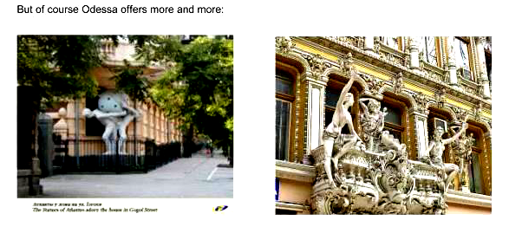
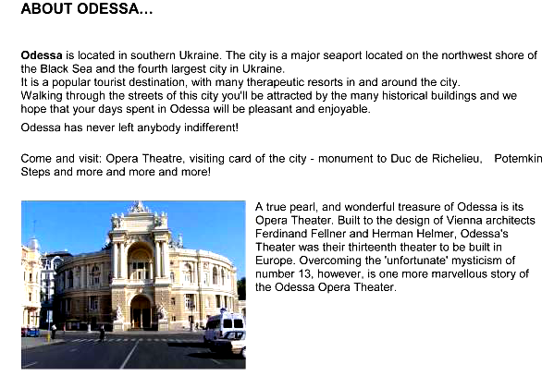

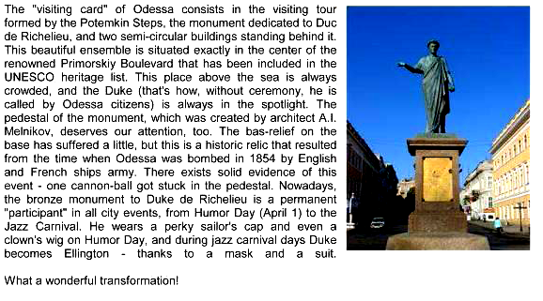

5) PROMOTER: Aleksandr Sosnin (Chairman and Technical Director of WCSA, 7-th Dan/Degree)

6) ORGANIZERS: “World Combat Self-defense Association”, “International Combat Organisation”, “World Combat and Kickboxing Organisation”

7) WEIGHT & PASSPORT CONTROL: 26th June 2013 (Koblevo -“ Vinnitsa”)

8) JUDGES AND REFEREES: Those who are interested in participation as judges and referees should inform, that they are going to attend a seminar. All Delegations are obligated to bring at least one (1) Judge or referee otherwise they will face a penalty

9) CONDITIONS FOR PARTICIPATION: Tournament begins 28th June at sport centre “Vinnitsa”. Allowed fighters of any styles and organizations with the necessary qualifications “WCSA” or “ICO” (Level), in accordance with the claimed section
competitions, with medical admission required and insurance. Each command has to have a national Flag and the Hymn (on CD-disk).

Starting fees:

- €25 – first division per participant
- €20 (15 € bonus) – extra division each
- €10 - athletic passport

The fighter can participate in different disciplines.

The annual membership fee – 10 € per athlete.

To attention of representatives of teams – every 10th participant receives a command bonus on accommodation, and also participation in a seminar and competitions.

Applications for tournament should be submitted before 10th June.
The team without submitted application will pay a penalty of € 10 per person.

In the absence of the equipment it can be rented.

10) ACCOMMODATION:
Price Hotel from 10 $ a day per person (comfortable rooms with baths)
Hotel “Vinnitsa”: http://www.koblevo.com/vinnitsa.html

For those who stay NOT in “Vinnitsa” hotel an entrance on the complex territory
will cost € 2 a day.

Information: e-mail: wcombatsd@gmail.com; combatsd@mail.ru

11) DIVISIONS:

DISCIPLINE RULES: WWW.COMBATSD.COM

“Demo-Defense”:

(admittance not lower “9 Level”)

Shadow-fights
Attack-tests up to10 years; 10-12 years; 13-15 years; 16+ years
Self-defense

Winners of disciplines are awarded by a medal and the diploma, if more than 3 participants.
10.1.1. Discipline – «Shadow Fights». Free demonstration of techniques of punches, kicks, dodging and bobbing (time of execution - 30-60 seconds).
10.1.2. The discipline - "Self-defense" (the executor + the assistant () – only the executor is asessed. Time of execution from 1,5 to 3 minutes
10.1.3. Discipline – «Attack-Tests». Testing with the assistant (trainer) on pads, with punches (1st round), kickes (2nd round) in a combination to possible dodges and the wrestle techniques with the partner of a corresponding weight category (3rd round). Execution time 3 rounds for 20 seconds.
In the given section the sportsman and his instructor are estimated. (2 medals).

«Safe-Point»:

(admittance not lower “8 Level”, class E not lower “9 Level”)

Equipment: a jacket and trousers (kimono), a helmet (type "safe"), protection of a shin and foot lifting, a groin protector. For girls the presence of a protector on a breast is necessary.
Fight lasts 90 seconds of pure time or to advantage in five points (gloves ММА or for hand-to-hand fight - And, In, About a class). Class D, Е, - 60 seconds.

Class Years Weight, kg
Men | 18-40 | -60 | -68 | -77 | -86 | 86+
Woman | 18-40 | -50 | -57 | 57+
Junior A-class (male) | 15-17 | -51 | -57 | -64 | -71 | -80 | 80+
Junior A-class (female) | 15-17 | -40 | -45 | -51 | -57 | 57+
Junior B-class (male) | 12-14 | -36 | -40 | -45 | -51 | -57 | 57+
Junior B-class (female) | 12-14 | -35 | -42 | -50 | 50+
Junior D-class (male) | 10-11 | -30 | -34 | -39 | -45 | 45+
Junior D-class (female) | 10-11 | -30 | -35 | -40 | 40+
Junior E-class (male) | 7-9 | -20 | -23 | -26 | -30 | -35 | 35+
Junior E-class (female) | 7-9 | -20 | -23 | -26 | -30 | 30+

«Mix-Wrestling»:

(admittance not lower “7 Level”, class C not lower “8 Level”)

Equipment: 1 round - jacket (GI), and shorts. 2 round- t-shirt and shorts.
Wrestling mixed section. The fight lasts 2 round 1.5 minutes each of effective time for the B, C-class and 2 minutes for the Men and A-class.
The points of each round are summed in the final result at the end of fight.

Class Years Weight, kg
Men | 18-35 | -60 | -68 | -77 | -86 | -95 | 95+
Junior A-class (male) | 15-17 | -51 | -57 | -64 | -71 | -80 | 80+
Junior В-class (male) | 12-14 | -36 | -40 | -45 | -51 | -57 | 57+
Junior C-class (male) | 10-11 | -30 | -34 | -39 | -45 | 45+
Categories are considered full in the presence of 4 participants, otherwise
The credentials committee has the right to combine neighbour categories
(The difference in weight can NOT be more than 20 %)

«Mixed Combat Arts»:
«Safe-Сombat»:

(admittance not lower “7 Level”, class D not lower “8 Level”, class E not lower “9 Level”)

Equipment: the top of the Kimono and the belt (appropriate rank), sport trousers that reach the ankles, helmet with plastic face guard (type "safe"), gloves (for ММА or hand-to-hand fight), a groin protector. Chest guard (for girls in all age categories and boys under 12 years).
The duration of the fight for adults 2 rounds for 2 minutes, A,B,C classes - 2 rounds for 1,5 minutes.
Class D - 2 rounds for 1 minute, at class Е -2 of a round for 45 seconds. Break between rounds for 30 seconds.
Any shock correct techniques in a rack, in a ground position attack by hands and feet at the torso, in a head only fixed blows by hands is resolved. Throw is a technical action from a standing position leads to falling the opponent on the ground (on side or back). Wrestling on the ground (strikes).Joint locks. Actions on a joint leading to capitulation of the opponent (10 seconds is given for completion). Chokes forearm, kimono or legs (10 seconds is given).On the ground punches and kicks into body and not more than 3 into head in succession

Class Years Weight, kg
Men | 18-35 | -60 | -65 | -70 | -75 | -81 | -87 | -93 | +93
Woman | 18-35 | -50 | -55 | -60 | -65 | -70 | +70
Junior A-class (male) | 16-17 | -55 | -60 | -65 | -70 | -75 | -81 | -87 | +87
Junior A-class (female) | 16-17 | -45 | -50 | -55 | -60 | +60
Junior B-class (male) | 14-15 | -45 | -50 | -55 | -60 | -65 | -70 | +70
Junior B-class (female) | 14-15 | -40 | -45 | -50 | -55 | +55
Junior C-class (male) | 12-13 | -35 | -40 | -45 | -50 | -55 | -60 | +60
Junior C-class (female) | 12-13 | -35 | -40 | -45 | +45
Junior D-class (male) | 10-11 | -30 | -34 | -39 | -45 | 45+
Junior D-class (female) | 10-11 | -30 | -34 | -39 | 39+
Junior E-class (male) | 7-9 | -20 | -23 | -26 | -30 | -35 | 35+
Junior E-class (female) | 7-9 | -20 | -23 | -26 | -30 | 30+
In all classes is used of a soft protector on a breast, is supposed (under a kimono).
In class D – the shock techniques in a ground position (the formula of fight 2 rounds for minute)
is forbidden
In class Е– ground position is prohibited (the formula of fight 2 rounds for 45 seconds).

«Light-Combat»
(admittance not lower “7 Level”)

Equipment: open helmet.Shorts, open type gloves with filler (not less than 4 cm), T-shirt dressed with shorts and chest guard, shin and instep guard, groin guard, mouthpiece. Chest guard for girls.
The duration of the fight 1 round - 2 minutes. Kicks and punches, applied to all levels, knees only to the body. Punches to the head only in Light contact. Series of more than 3 punches to the head must be stopped by the referee. On the ground locks and chokes are allowed (10 seconds for attempt). No strikes on the ground.

Class Years Weight, kg
Junior B-class (male) | 14-15 | -45 | -50 | -55 | -60 | -65 | -70 | +70
Junior B-class (female) | 14-15 | -40 | -45 | -50 | -55 | +55
Junior B-class (male) | 12-13 | -40 | -45 | -50 | -55 | -60 | 60+
Junior B-class (female) | 12-13 | -35 | -40 | -45 | 45+

«Free - Combat»
(admittance not lower “6 Level”)
Equipment: open helmet, shorts, open type gloves with filler (not less than 10 oz), shin and instep guard.
The duration of the fight two rounds for 2 minutes, with a break for 30 seconds - adults, and a 2*1,5-A class (are possible 3 rounds of fight in the finals).
Full-contact kicks and punches, applied to the body and legs. In clinch (standing position) up to 10 sec inactivity.On the ground up to 10 sec inactivity. No strikes on the ground.
«Mix-Combat» :
Class Years Weight, kg
Men | 18-35 | -60 | -65 | -70 | -75 | -81 | -87 | -93 | +93
Woman | 18-35 | -50 | -55 | -60 | -65 | -70 | +70
Junior A-class (male) | 16-17 | -55 | -60 | -65 | -70 | -75 | -81 | -87 | +87
Junior A-class (female) | 16-17 | -45 | -50 | -55 | -60 | +60
(admittance not lower “4 Level”)

Equipment: bare torso, shorts, gloves for MMA with the protection of the thumb, helmet without plastic face guard, shin and instep guard, groin guard, mouthpiece.
Any shock correct techniques in a rack. Kicks and punches in the front, side and top of the head covered by helmet. Low-kicks, elbow strikes to the body (standing and on the ground), knee strikes (on the ground only to the body). punches and kicks into head and not more than 3 into head in succession.
Class Years Weight, kg
Men | 18-35 | -60 | -65 | -70 | -75 | -81 | -87 | -95 | +95

champion belt
12) CONTACT: +7 917 761 90 80; +7 963 131 72 27 - Aleksandr Sosnin
+7 927 313 30 17 - secretary

13) CONTACT – VISA DOCUMENTS:
For more Information or Visa Documents please contact:
e-mail: wcombatsd@gmail.ru
Visa is not required for citizens of the EU, the UK, the USA, Israel, Japan and some other countries. For further information contact the nearest consulate or embassy. http://www.mfa.gov.ua/mfa/en/publication/content/1865.htm

 | Registration form – “Black Sea -2013”
 | Competitors
 | Name | Country/Club |  | № WCSA passport | M / F | Age |  | Weight | DD |  | SP |  | SC | MW |  | LC | FC |  | MC |  | Level/  Degree
1
2
3
 | Coaches / Representatives
 | Name |  | Country/Club |  |  |  | coach/representative/…
1
2
3
 | Referees / Judges
 | Name |  | Country/Club
1
2
3

M/F= male or female
DD- Demo-Defense LC – Light-Combat
SP – Safe-Point FC – Free-Combat
MW – Mix-Wrestling MC – Mix- Combat
SC – Safe-Combat
Arrival & Departure Details

Country:……………………………………………………………………………………………………..
National Federation/Association's Name:………………………………………………………………………………………………….
Name of Representative:…………………….…………………………………….………………………..
Address:………………………………………………………………………………………………………………………………………………………
E-mail:…………………………………………………………………………………………………………
Telephone / Fax:…………………………………………………………………………..…………………

Flight Schedule:
Date of Arrival: …………………………… ………. Time of Arrival:…………………. …………………. No. of Persons:…………………………………… Flight No:…………………………………………… Airline Name:……………………………… …..…………………………………………………………….
Date of Departure: …………………………… ……Time of Departure:………………………………… No. of Persons:…………………………………… Flight No:…………………………………………… Airline Name:……………………………… …..…………………………………………………………….



